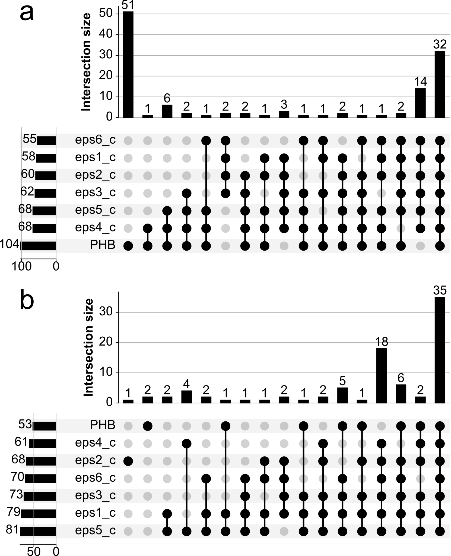

**S3 Fig. Gene essentiality analysis for the production of PHB and EPSs under aerobic and anaerobic conditions using different carbon sources.** **A** Upset plot with 20 distinct groups of lethal genes for PHB and six EPSs under aerobic conditions. **B** Upset plot with 19 diverse groups of lethal genes for PHB and six EPSs under anaerobic conditions.